**ANIMAL SCIENCE ASSOCIATION OF NIGERIA**

**1st Floor Press House (PM News) 27, Acme Road, Agidingbi, Ikeja, Lagos.**

: +234-817-202-5809, +234-817-202-5803, +234-803-423-9319.

Website: animalscienceassociation.org.ng *Email: [animalscienceassociation@yahoo.com](mailto:animalscienceassociation@yahoo.com), [admin@animalscienceassociation.org.ng](mailto:admin@animalscienceassociation.org.ng), [enquiries@animalscienceassociation.org.ng](mailto:enquiries@animalscienceassociation.org.ng)*

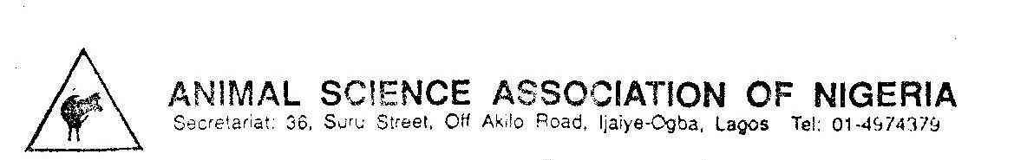

Recent Passport Photograph

**2020 ELECTION NOMINATION FORM**

FULL NAME OF ASPIRANT WITH TITLE ………………………………..................................

CONTACT ADDRESS/EMAIL/PHONE NO………………………………………………………

……………………………………………………………………………………………….

STATE OF ORIGIN………………………………………………………

QUALIFICATION(S) WITH DATE……………………………………........................................

EMPLOYER (include Name of Organization, Address, Email & Phone no)…………………………..

…………………………………………………………………………………………………………..

POSITION DESIRED………………………………………………………………………

ASAN REGISTRATION NUMBER……………………………………………………….

LIST RECORDS OF SERVICE TO ASAN / PROFESSION ( Local and National)

…………………………………………………………………………………………………………

………………………………………………………………………………………………………….

………………………………………………………………………………………………………….

………………………………………………………………………………………………………….

…………………………………………………………………………………………………………..

SIGNATURE & DATE……………………………………………………..

FULL NAME OF 1ST SPONSOR WITH TITLE……………………………………………………….

ADDRESS/EMAIL/PHONE NO……………………………………………………………………….

SIGNATURE & DATE………………………………………………………..

FULL NAME OF 2ND SPONSOR WITH TITLE………………………………………………............

ADDRESS/EMAIL/PHONE NO……………………………………………………………………….

SIGNATURE & DATE…………………………………………………

*Please attach evidence of financial standing/Clearance for the last three (3) years*

**FOR OFFICE USE ONLY**

Eligibility/Nomination Status

1. Qualified to contest: ----------------------------------------------------------------------------------
2. Not qualified to contest [please give reason(s)]: --------------------------------------------------

OFFICER’S NAME & SIGNATURE-------------------------------------------- DATE-----------------